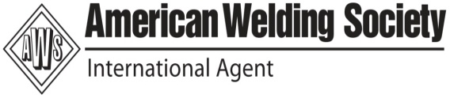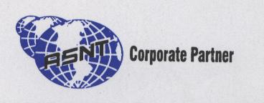

- Eddy Current Testing – 10 Days
- How to prepare WPS,PQR & WPQ – 3 Days
- Seminar on Industrial Application of Guided Waves,PAUT,TOFD
- Metal Properties, Destructive Testing & Non Destructive Testing
- Welding Process, Weld Geometry, Symbols and Weld Discontinuity
- Materials and Metallurgy for Engineers
- Failure Analysis of Industrial Components
- Introduction of Metal Casting & Discontinuity Removal Process & NDT

BETZ EDUCATIONAL & RESEARCH DIVISION
21- Dharakeshwari 1st Street , Sembakkam, Tambaram
(Tambaram to Velacherry main road )
Chennai – 600 073 , Phone # 044-22780291/Mobile # 9551665682/83
E-mail : info@ welding-certification.com / seminar@welding-certification.com
Web : www.betzinternational.com/www.welding-certification.com

